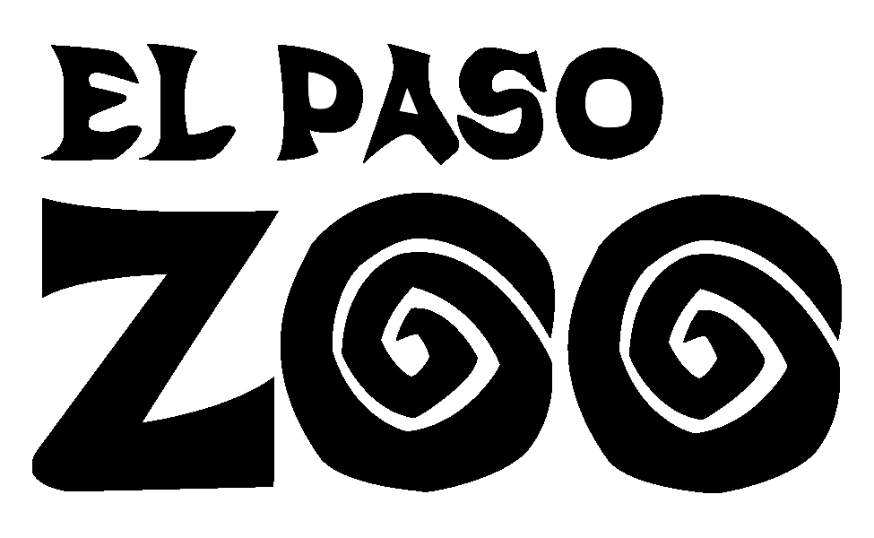
EDUCATION DEPARTMENT
Zoo Adventure Program
“Venomous Animals”
Teacher’s Extension

Grade Level: 4th - Adults
Duration: 30 to 90 minutes
Setting: Maximum of 40 students

Summary:
The Zoo Adventure Venomous program encourages students to become familiar and identify animals that are perceived to be scary and favorable in the El Paso area.
Objective: Students will be able to recognize the value of animals’ contributions to ecosystems-even those that people sometimes respond to with fear.
- Students can draw and research further on their favorite scary or favorable animals that were presented during the “Venomous Program.”
- Write a short story about each, including the value of each and their contribution to the Chihuahuan Desert.
- Using the animals that were presented, classify animal groups; e.g., mammals, spiders, insects, etc. Which groups seem to be most “loved,” “feared,” etc.
- Work in small groups to select an animal that has a negative image for some people.
- Write an advertisement or produce a simulated television commercial for that animal and include the positive things the animal does for the community.
- Share results with the rest of your class and send them to your El Paso Zoo. Attention: Education Department 4001 E. Paisano, El Paso, Texas 79905
Supporting Materials:
www.elpasozoo.org
www.aza.org
.www.projectwild.org

